I Voted!  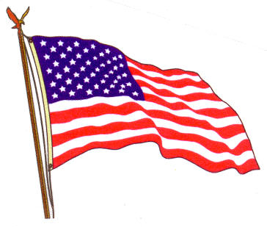 |  | I Voted! |  | I Voted!
I Voted! |  | I Voted! |  | I Voted!
I Voted! |  | I Voted! |  | I Voted!
I Voted! |  | I Voted! |  | I Voted!

