THE OTER

V
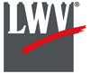

We respectfully acknowledge that we are on the traditional land of the Yakama People.
This Newsletter published by and for the
League of Women Voters of Yakima County
PO Box 723 Yakima WA 98907 509-452-3419
November, 2019
Vol.19, No 11

CALENDAR

Tuesday, November 19, 5:30 PM November Conversation: Health and Evnvironment Impacts of Climate Change in Central Washington by Sara Cate, M.D. Wesley United Methodist Church, 14 N 48th Avenue, Yakima. See attached flyer.

Sunday, December 1, 1:00 PM Decorate League Christmas Tree for Museum Event. LWVYC office at Unitarian Universalist Church, 225 N 2nd Street, Yakima.
See article in this issue.

Monday, December 2, 4:00 PM Leadership Team Meeting. LWVYC office at Unitarian Universalist Church, 225 N 2nd Street, Yakima.

MISSION STATEMENT
Empowering Voters. Defending Democracy.

VISION
We envision a democracy
where every person has the desire,
the right, the knowledge, and the confidence
to participate.

VALUE STATEMENT
The League believes in the power of women to create a more perfect democracy.

March 26

April1, 4 PM

Officers
President: Criss Bardill
Secretary: Karen Pilon
Treasurer: Janis Luvaas

Board of Directors
Quinn Dalan
Cynthia Garrick
Rhonda Hauff
Kitty Jubran
Susan Kaphammer
Cheri Kilty
Kathy Lambert
Joan Robertson
Marilyn Shearer
Elaine Smith

Voter Editor: Susan Kaphammer
949-0127; susanlkap@gmail.com

The Board meets at 4:00 PM the 1st Monday of each month at the League office.
All members are welcome to attend.

NOTES FROM CRISS

Eleven members of our League and 11 State League Board members gathered for a potluck on Sunday, October 20, at the comfortable and convenient clubhouse at Becky Scholl’s condo complex, and it was a lively and fun event! Kudos to new State President Lunell Haught for initiating this opportunity for local Leagues and State Board members to have time to socialize, share ideas, and hear about current issues and efforts at both the state and local League levels.
We were disappointed to have to cancel our Wapato City Council Forum. We need to be building more bridges to and interaction opportunities with our smaller communities in Yakima County, so we may overcome any perceptions of being outsiders trying to influence local politics. In that regard, Jackie and Jim Hertel and my husband Mike and I attended the Filipino American
(Continued on Page 2)

The Voter, November, 2019 Page 2

NOTES FROM CRISS (Continued from Page 1)

History Month Dinner in Wapato on October 27. League members Dori Baker-Preralta and Carrie Huie-Pascua are active in the Filipino American Community of the Yakima Valley. As well as enjoying a delicious and authentic Filipino dinner, we welcomed the opportunity to support this organization and our League members.
Please help spread the word on our next League Conversations on November 19th with Dr Sara Cate. (flyer attached). Dr. Cate is very knowledgeable about the climate change health issues in Central Washington, and we believe this will be an interesting and highly informative presentation for our local community. Note: our Conversations are normally scheduled for the last Tuesday of the month. We have shifted to the 3rd week in November to avoid Thanksgiving week.

IN THIS SEASON OF GRATITUDE

…it is good to re-visit this reminder from the handout provided by Katherine Murphy at our September Conversation. Despite the challenges, we can give thanks for all that has helped our nation, state, and city be places where we can live and thrive. Let’s recommit to making them even more so!
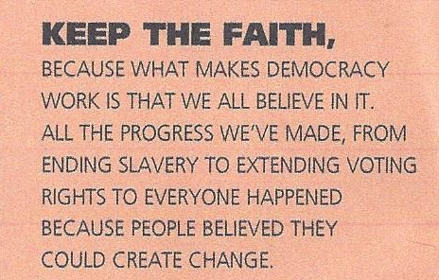

LWVYC NON-PARTISANSHIP QUESTIONED

Based on observing the League-sponsored Yakima City Council Candidates Forum, Bruce Smith, Publisher/Editor of the Yakima Valley Business Times, questioned our actions and intent. He published the following:
League of Liberal Women Voters? The local League of Women Voters calls themselves non-partisan, which they may be. Not likely, but possibly. What they clearly are, though, is ideaologically homogenous. It seems like everything they do has a liberal bent to it. Now that’s true of other non-partisan groups around here, including some on the other side of the field from LWV, like the Central Washington Homebuilders Association. But the league bristles whenever anyone points out this obvious fact.
I was reminded of that the other day when I watched the league’s “debate” of some of the candidates running for the Yakima City Council. Here are some of the questions that were posed:
- Do you support programs to reduce the city’s use of fossil fuels?
- What will you do to support a walkable, vibrant downtown, now that the plaza has been killed?
- How are you going to address equity issues in Yakima?
- Do you support expansion of Yakima Transit hours and possible expansion of service countywide?
Now, why would anyone think that group leans to the left?
The following letter has been sent to help Mr. Smith understand our organization.
(Continued on Page 3)

The Voter, November, 2019 Page 3

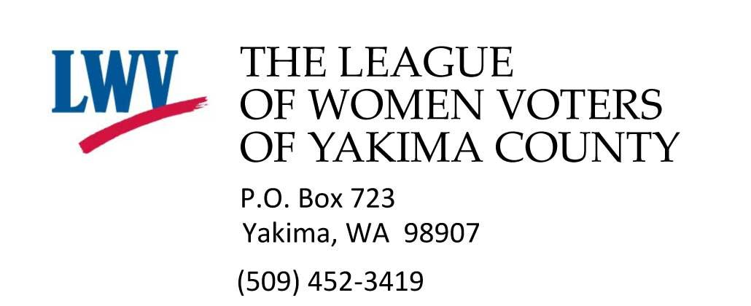
Empowering Voters. Defending Democracy.
November 8, 2019

Yakima Valley Business Times
416 S 3rd Street
Yakima WA 09001

Dear Mr. Smith,

It was with interest that I read your thoughts on the League of Women Voters in the current issue of the Yakima Valley Business Times. I want to clarify the League’s non-partisan policy, which is separate and distinct from its consensus policy positions. The League’s non-partisan policy is as follows:
“The League of Women Voters is a nonpartisan political organization. We encourage the informed and active participation of citizens in government. The League acts in support of, or in opposition to, selected governmental issues which its members have studied. It does not support or oppose candidates, factions or political parties. League members, as individuals, may support candidates of the political party of their choice.” (League of Women Voters US)
In response to your examples of questions asked at the recent Yakima City Council Forum, our members and friends of League are invited to submit questions to put forth to candidates at the forum. Attendees at the forum event itself are provided note cards to submit questions. We screen questions for duplication and to the relevance to the position being sought. Unfortunately, it is true that at most forums we receive more questions than time allows, but no question is eliminated because we decide we don’t want that writer’s viewpoint expressed.
It is also true that the LWV has long supported a progressive agenda, starting with the League’s formation a hundred years ago during the battle for granting women the right to vote, certainly a highly controversial and progressive stance at the time.
Over the years, the League has worked hard to improve the legal status of women and the welfare of children and to improve legislation protecting the consumer. Current policy positions at the national League level includes fighting voter suppression, limiting big money and donor secrecy in politics, opposing racial and partisan gerrymandering in redistricting, and building diversity, equity and inclusion throughout the LWV organization.
For most of its history, the League of Women Voters enjoyed the membership of people from both the major parties, as well as those with minor party affiliation and independents. It is a sad consequence of the recent political climate of hyper partisanship that many have moved to the far corners of that
partisanship, with disdain for those that would dare come to the center for open dialogue with mutual
(Continued on Page 4)

The Voter, November, 2019 Page 4
(Letter to Bruce Smith, Continued from Page 3)
respect and the goal of in-depth study of policy issues. It is always our goal to encourage and sustain thoughtful study and respectful debate in forming our consensus positions.
In closing, I invite you to join us as a member, and have attached a membership form. Your interest in us and your input as a member could broaden our awareness and understanding of issues of concern to you as a conservative community activist. We have also added you to our monthly Voter newsletter email distribution so that you can be aware of our current activities and policy stances.
Respectfully,
Criss Bardill, President
League of Women Voters of Yakima County

Enclosure:
LWVYC Membership Application

LWVYC Co-Sponsored Event…
2019 YAKIMA HATE CRIMES FORUM HELD
On October 15th, the NAACP, LWV Yakima County, and the OIC co-sponsored a Hate Crimes Forum at the Henry Beauchamp Community Center. Seven panelists addressed the legal definition of hate crimes and the extent of the problem in Yakima County; how to report a hate crime as a witness or target; local community concerns; and services and resources available. League member Steve Hill moderated the panel and the following Q&A and public comments.
Panelists were Bre Weider, Policy Analyst with the WA State Office of Attorney General; Shannon Welch, FBI Special Agent, Seattle; Mathew Tomaskin, Yakama Nation; Yakima County Prosecuting Attorney Joe Brusic, Yakima County Sheriff Robert Udell, Yakima Police Chief Matt Murray; and Mohan Singh of the Sikh Guwara Singh Sabha (Sikh Temple) in Yakima.
All the speakers spoke of the importance of reporting, the suspected underreporting of hate crimes or incidents, and some of the social and cultural barriers victims or observers experience. FBI Special Agent Welch spoke to the need for a strengthened domestic terrorism statute, which has been put forward at the national level but not passed. See article explaining proposals: https://www.lawfareblog.com/proposed-bills-would-help-combat-domestic-terrorism
Mathew Tomaskin spoke movingly of the Native American historic and ongoing experience of hate crimes since first contact, and Mohan Singh emphasized the need for respect for all human beings and the recognition of God in every person.
The League appreciated the opportunity to be a co-sponsor for this event, attended by about 30 community members. This write-up in the Herald Republic relates some the issues of reporting and the community comments and experiences that were shared: https://www.yakimaherald.com/news/local/officials-call-for-community-reporting-on-hate-crimes-which-often/article_3eabf90e-1587-582a-b6f6-48f76d4cad1e.html

The Voter, November, 2019 Page 5

October Conversation…
EL CENSO 2020 EXPLAINED

On October 22, our League Conversation featured members Dori Baker and Carrie Huie Pascua who talked about their work with El Censo 2020 and the importance of everyone participating in the census taking place in the Spring of 2020. The goal is to count every person living in the U.S. wherever they are living on April 1, 2020, including all ages regardless of immigration status.
The census form will be available in 13 languages. For the first time, people will be directed to respond online; however, responding by mail will be available. Dori and Carrie emphasized that there is a lot at stake including how tax dollars are spent; who gets roads, schools and other services; and who is represented in government.
The Census Bureau needs help to ensure a fair, accurate and safe count. As there are fewer public resources for outreach, communities need to work together to ensure a good count. We can all encourage people in our communities to get counted. Start conversations with friends and family and help people fill out the census online when needed.
You can learn more from the website: 2020 Census Resources and Action Kit at www.washingtonnonprofits.org/2020census.

LWVYC Project…
HELP PREPARE LEAGUE TREE FOR YAKIMA VALLEY MUSEUM CHARITY CHRISTMAS TREE EXTRAVAGANZA

The Leadership Team has committed our League to participating in the Yakima Valley Museum Charity Christmas Tree Extravaganza. Our theme will be the 100th Anniversary of both the League of Women Voters and the 19th Amendment (1920-2020). Our participation will increase community awareness of our local league as well as bring attention to these historical milestones.
League friends Kim Brewer and Rick Main are going to be our designers, and on Sunday, December 1, at 1 PM we will gather at the League office to decorate our tree which will be set up at the Museum from Dec 3 through December 14. We are looking for helpers for that Sunday and for tree ornament ideas. If you have non-partisan political pins, we would like to borrow them to use as tree ornaments and would make sure to return them to you. Our dominant colors will be the Suffrage scheme of purple for loyalty and dignity, white for purity, and green for hope, but political pins can be of any color.
If you’re handy with your fingers (not my strength!) would you be willing to work on some bows at home? We would get materials to you. If you Google ‘Suffrage Christmas ornaments’ you will see lots of ideas and items for sale. If you were so inclined, any ornaments you purchase would be returned to you; just be sure to get them to us prior to December 1 for use on the tree. Café Press also has numerous button like ornaments under “Suffrage ornaments:” https://www.cafepress.com/+suffrage+ ornaments and under “Suffragette ornaments:” https://www.cafepress.com/+suffragette+ornaments
Another alternative for you to support this endeavor is to make a donation for purchasing Christmas tree balls, ribbon, etc, as we will not be funding this out of our operating budget. Please give me a call at 965-2351 or email me at cbardill@gmail.com if you would like to contribute or give some hands-on help. Our decorate-the-tree gathering will include some seasonal treats, Christmas music, and lots of good cheer!
Lastly, plan to visit the Museum during the Charity Christmas Tree Extravaganza and put in your “votes” for our tree! -- Criss Bardill, LWVYC President

.
The Voter, October, 2019 Page 6 P
LWVYC Project…
YAKIMA LEAGUE PROMOTING CIVICS EDUCATION WITH KIDS VOTE USA CURRICULUM

We in the Yakima League have a wonderful new opportunity to contribute to the civics education of all students in Central Washington. This is possible because the Clallam County League purchased the K-12 curriculum Kids Vote USA for the entire state, and for the cost of printing materials every school district can offer age appropriate lessons on voting and why it matters.
On October 17, Criss Bardill and I presented the materials and the book The State We're In, published by the Washington State League, to the 25 district Superintendents within ESD 105. This comes at a time when school districts all across the state are looking for curriculum to meet new state requirements to teach civics, so you can understand their interest. We also offered help in training to use the curriculum.
The curriculum is a mix of traditional civics information and real life voting opportunities to use in class. There is an electronic component to allow teachers to create ballots and for students to vote on them. There is a strong family connection in having students discuss issues with parents. These issues can be school related for the younger grades, or State and National issues for older students. Research shows that when this curriculum is taught, voter participation goes up. In addition there are lessons teaching ways to discuss issues or proposals civilly.
In addition to providing the curriculum, the League here in Yakima County can help train classroom teachers. The Clallam County school district is currently using Kids Vote USA and their trainer has offered to help us get started here. Kevin Chase, Superintendent ESD 105, is enthusiastic for the ESD to be the place where training occurs. Right now, the District Superintendents have seen the materials and are back in their districts discussing the new social studies standards. We have offered these two fine resources to teach civics. Let the fun and hard work begin. -- Kathy Lambert

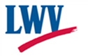
League of Women Voters of Yakima County

Cordially invites you to: JOIN US!

Name:________________________________________________ Date:_______________

Address:__________________________________________________________________

Phone:____________________________ E-Mail: ________________________________

Membership: ______$60 Basic______$40 Each additional family member at same residence
Make checks payable to:
LWVYC
PO Box 723
YAKIMA WA 98907
Sustaining Gift: $60 _____ $40 _____ $25____ Other_______
Your Sustaining gift will help support our local activities.

*Please Note Annual Dues Distribution:
National: $32 State: $19 LWVYC reta

VOTER INFORMATION WEBSITES

Secretary of State LWVWA- Vote 411 Yakima County Auditor
www.secstate.wa.gov/ www.VOTE411.org http://yakimacounty.us/170/Elections

