THE OTER

V

We respectfully acknowledge that we are on the traditional land of the Yakama People.
This Newsletter published by and for the
League of Women Voters of Yakima County
PO Box 723 Yakima WA 98907 509-452-3419
May, 2020
Vol.20, No 5

CALENDAR

Online: May 29 – June 7. League of Women Voters of Washington State Council. Via Zoom. See Notes from Criss on Page 2 and article on Page 3. Register now!

Online: Monday, June 1, 4:30 PM. Leadership Team Meeting. Via Zoom. Check email for details.

Online: Monday, June 15, 4:30 PM. LWVYC Annual Meeting. Via Zoom. Watch for email for details. All members encouraged to participate!

Looking ahead:

Tentative: Tuesday, June 23; 5:30 PM. League Conversation. (Topic To Be Announced.) Wesley United Methodist Church, 14 N 48th Avenue, Yakima.

MISSION STATEMENT
Empowering Voters. Defending Democracy.

VISION
We envision a democracy
where every person has the desire,
the right, the knowledge, and the confidence
to participate.

VALUE STATEMENT
The League believes in the power of women to create a more perfect democracy.

March 26

April1, 4 PM

Officers
President: Criss Bardill
Secretary: Karen Pilon
Treasurer: Janis Luvaas

Board of Directors
Quinn Dalan
Cynthia Garrick
Rhonda Hauff
Kitty Jubran
Susan Kaphammer
Cheri Kilty
Kathy Lambert
Marilyn Shearer
Elaine Smith

Voter Editor: Susan Kaphammer
949-0127; susanlkap@gmail.com

The Board meets at 4:00 PM the 1st Monday of each month at the League Office at the UUCY Church, 225 N 2nd Street, Yakima
All members are welcome to attend.

Help for LWVYC Members…

LEARNING TO USE ZOOM
You will notice that in these unusual times our local and State LWV have taken to using Zoom instead of in-person meetings. If you are unfamiliar with this online meeting tool, help is on the way so you, too, can come “Zooming into League!”
Our Leadership Team will be working with state resource people and materials to give our members a hand up into productively using Zoom to do League work. Watch for email notices.
Meanwhile, if you want to get a start on understanding Zoom, check out these brief (2 min. and 1 min. videos):
Zoom 101 Sign Up and Download Meeting Client on YouTube; and Joining a Meeting from the Zoom website.
The Zoom website at zoom.us offers getting started help by clicking on “Support” in the upper right corner.

Page 2

co

The Voter, April, 2020 Page 2

The Voter, May, 2020 Page 2

LWVYC President’s Column…

NOTES FROM CRISS

As I write this, I am feeling thankful for our beautiful spring weather, and the gorgeous blooming trees and gardens across our County. It helps my attitude and my mental health in this struggling time.
And having League work and affairs is also a help – our important work must continue!
Registration for the virtual 2020 State Council is now open, and as a member of the Council committee, I can relate how excited and pleased we are with registration activity. We had over 100 participants as of last Wednesday! As this is a first time experience, we didn’t really know what to expect, so we are very happy to see the commitment so many Leaguers are making to attend. If you have not yet registered, see the information and link on page 3 in this issue of The Voter. If you register, you will receive a free facemask made of fabric designed by Amy Peloff in our State Office that features our logo and the word VOTE in a red, white and blue design. Training in Zoom will be provided to those who need it. And if you are registered, you have already received the first of several follow-up emails giving guidance and instructions to registrants.
On Monday, May 11, a Census 2020 street banner was hung in downtown Yakima, courtesy of our League. Banners were made available at no cost by the WA State Census office, and we are paying for the cost of installation and the corresponding fee to the City of Yakima. Our Census 2020 response numbers are still quite low in Yakima County, and we hope the banner will be an important reminder to those who have not yet completed their Census. See the photo below!
At our Leadership Team meeting on May 4 we made the difficult decision to hold our Annual Meeting of the League of Women Voters of Yakima County, scheduled for June 15th, online via Zoom, starting at 4:30 PM. We will be providing training to members who need help learning to Zoom, and hope you all will be able to participate. Please watch for emails as we get organized to do this.
The State League Nominating Committee is gearing up for the 2021 election of Board members and State Committee members. Please let me know if you have any possible interest in serving the League at the State level. With everyone’s growing comfort with virtual meetings, the issue of traveling to meetings on the Westside is diminishing quickly. I believe our State League is enhanced when the leadership is balanced with a healthy participation from the Eastside.
And even though you may be getting tired of your confinement, please “Stay Home, Stay Healthy”!

Civic Education and Engagement Project…

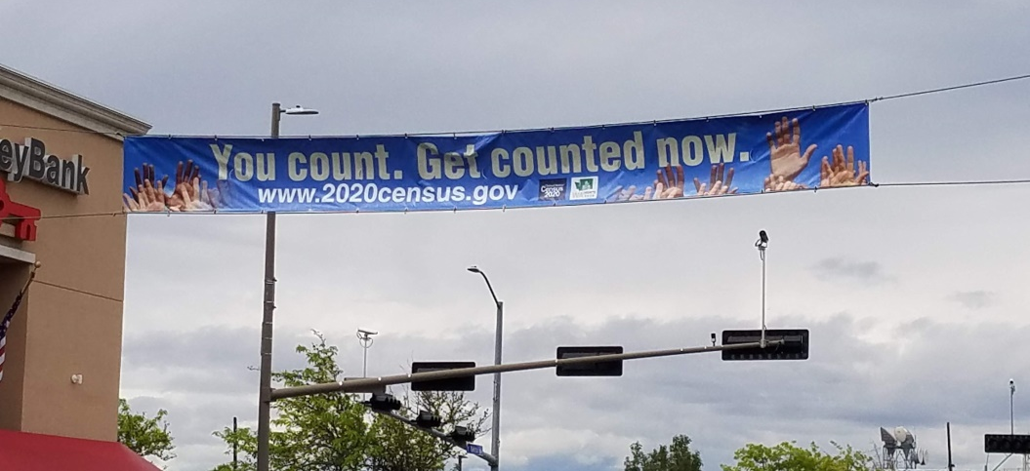
CENSUS BANNER OVER YAKIMA AVENUE

The virus has curtailed our League’s planned activities to promote the census. But this banner carries the message to all who drive through Downtown Yakima.

The Voter, May, 2020 Page 3

LWVYC Fundraising Appeal…

GRATIFYING RESPONSE RECEIVED FROM MEMBERS

We are deeply grateful to the following members who have responded so generously to our fund raising letter sent out in April. The list of contributors as of now includes:

Clara Eustis Elaine Smith
Kathy Lambert Steve Hill
Jackie Hertel Marilyn Shearer
Joyce Dennison Anita Monoian
Bill Faller Kathy Hagen
Millie Stenehjem Criss Bardill
Rhonda Hauff Janis Luvaas
Jackie Call Kay Funk
Kitty Jubran Eleanor Hungate
Sister Mary Ellen Robinson Cynthia Garrick
Deborah Severtson-Coffin

Plan Now to Attend State League Council…

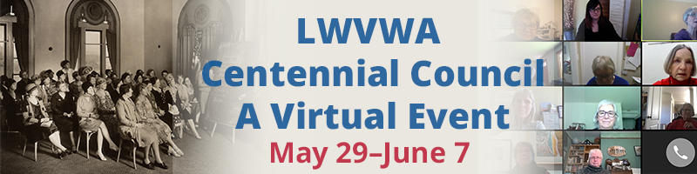

Increase your knowledge of important issues! Celebrate the 100th anniversary of the 19th Amendment with like-minded activists! Hear from and talk with state and national leaders in the League! Learn how to be effective in defending democracy! And have a lot of fun! All at minimal cost from your own home!
Registration is only $19 if done today for up to 14 online sessions scheduled throughout the week. Choose just a couple of sessions, or sit in on all of them – your choice. “Be there” by computer or phone connection through Zoom. Handouts will be made available for those who are just listening in, and sessions may be recorded for later viewing.
Check the complete schedule and register for this Virtual Centennial Council from the League of Women Voters of Washington website at https://lwvwa.org/centennial-council/.

And as a bonus, your registration fee will include a special League face mask with this pattern. You can wear this through the fall to stay safe while encouraging voting.

The Voter, May, 2020 Page 4

LWVWA Action Alert…

Legislators are Planning for a Special Session –
Tell Them to Address Inequities

Given the impact of COVID-19 on the state’s economy, it is likely that the Legislature will be called into special session sometime this summer to make adjustments to the State’s budget. We are aware that conversations among legislators are already underway to prepare for that session, once it is called.
The League of Women Voters Lobby Team and Board would like to impact the legislators’ thinking in their pre-planning about how they can remediate some of the long-standing and undeniable racial and economic disparities that have become even more glaringly obvious during the COVID-19 crisis. Data in every state indicates that people of color have been significantly disproportionately harmed by the COVID-19, both in health and financially, and this is true in Washington as well. Additionally, people of color are more likely to lose their housing in the aftermath, joining the already disproportionately high ratio of people of color who are experiencing homelessness. Further, job losses will lead to problems assuring health care coverage.
The League has sent letters to the Legislature and the Governor asking that these matters be addressed. A copy of the letter sent to legislators can be seen here.
You can help convey the importance of this by clicking here to email your Legislators to reinforce these same messages.
Released May 6, 2020, by Ann Murphy, Lobby Team Chair.

League of Women Voters of Yakima County
Cordially invites you to: JOIN US!

Name:________________________________________________

Date:_______________

Address:__________________________________________________________________

Phone:____________________________ E-Mail: ________________________________

Membership: ______$60 Basic______$40 Each additional family member at same residence

Sustaining Gift: $60 _____ $40 _____ $25____ Other_______
Make checks payable to:
LWVYC
PO Box 723
YAKIMA WA 98907
Your Sustaining Gift provides additional support for our local activities.

*Please Note Annual Dues Distribution: National: $32
State: $19
LWVYC retains: $ 9

VOTER INFORMATION WEBSITES
Secretary of State www.secstate.wa.gov/

LWVWA- Vote 411 Yakima County Auditor
www.VOTE411.org http://yakimacounty.us/170/Elections

