THE OTER

V



This Newsletter published by and for the

League of Women Voters of Yakima County

PO Box 723, Yakima, WA 98907 509-452-3419

*We respectfully acknowledge that we are on the traditional land of the Yakama People.*

March, 2021

Vol.21, No 3

**CALENDAR**

Tuesday, March 16, 6:00 to 7:30 PM **Improving Representation in Yakima County for People of Color Through Redistricting in 2021:** Via Zoom: <https://zoom.us/j/91407172280> *See article on p 2 and flyer*

Tuesday, March 22, 12 Noon to 3 PM **LWV Speak-Up School Redistricting Workshop.** Via Zoom. Register at [tinyurl.com/SpeakUpMar22](http://tinyurl.com/SpeakUpMar22). *See article on p 3 and flyer*

Tuesday, March 23, 5:30 PM **League Conversation:  Affordable Housing in Yakima County** by Jake Mayson.Via Zoom. *See announcement below and article on p 4*

Monday, April 5, 4:30 PM **Leadership Team Meeting.** Via Zoom. *Watch email for Zoom link.*

***Coming***

***soon!***

**MISSION STATEMENT**

Empowering Voters. Defending Democracy.

**VISION**

We envision a democracy

where every person has the desire,

the right, the knowledge, and the confidence

to participate.

**VALUE STATEMENT**

The League believes in the power of women to create a more perfect democracy.

March 26

+-

**Officers**

*President:*  Criss Bardill

*Secretary:* Karen Pilon

*Treasurer:* Janis Luvaas

**Leadership Team**

Quinn Dalan

Rhona Hauff

(*also Membership*)

Kitty Jubran

Susan Kaphammer

Cheri Kilty

Kathy Lambert

Anita Monoian

Lee Murdock

*Voter Editor:* Susan Kaphammer

949-0127; susanlkap@gmail.com

The Board currently meets at 4:30 PM

the 1st Monday of each month via Zoom.

**All members are welcome.**

Contact Criss Bardill at 509-965-2351 or at [cbardill@gmail.com](mailto:cbardill@gmail.com) to “attend”

***League Conversation …***

**AFFORDABLE HOUSING IN YAKIMA COUNTY**

Discussion led by **Jake Mayson,**

CWHBA Government Affairs Director

With **Joseph Calhoun**

City of Yakima Planning Manager

**Tuesday, March 23, 2021**

**5:30 PM**

Join at Zoom Link: **[https://us02web.zoom.us/j/82241794410](https://us02web.zoom.us/j/82241794410?pwd=L2hwWjZiOWtlcTIxdWlUMlV5dnVoQT09" \t "_blank)**

Or Dial from your Phone: (253)215-8782

Meeting ID: 822 417 94410. Passcode: 190811

Or Watch live on the LWVYC Facebook page.

*League Conversations:*

*Informing the public on topics of interest.*

*Page 2*

****

**co**

***The Voter,*** *March, 2021 Page 2*

***LWVYC President’s Column…***

**NOTES FROM CRISS**

I hope many of you have received your Covid vaccinations; it has been encouraging to see the increases in the availability of vaccines, and now J&J single shot vaccine is here. As everyone seems to be saying, we are hopefully seeing the light at the end of the tunnel! But any celebration of that will be tinged with the recognition of the terrible toll the pandemic has taken on our great country. The loss of life, the “long” Covid phenomena that so many are experiencing in their recovery, the economic hardship that has fallen heaviest on our least economically secure, is heart breaking. As the USA begins to recover and heal, I deeply hope it will be with a renewed recognition of our collective need to create an economy that works for all people, and that universal healthcare moves from aspirational to reality.

The Speak Up School has been scheduled for Monday, March 22, noon to 3 PM. This will be the opportunity for those interested in testifying at the coming Redistricting Committee Hearings to polish their skills and the points they want to make. Your interest is invited, even if you are not sure you want to testify. A consortium of Central Washington groups and people have been paving the way for the Speak Up School with Zoom sessions on Redistricting 101 and Train the Trainers/Coaches. I am impressed and pleased with this effort and the number of people involved. I believe it will lead to the Redistricting Commissioners hearing from lots of people in Central WA about our concerns and hopes for the redistricting process. The flyer and the link for registration in is this Voter, and I hope to see you there!

The Leadership Team has scheduled our 2021 Annual Meeting for Monday, May 24. We are hoping for nice weather and the opportunity to gather in person, possibly outside, if regulations and guidance allow for that by then. If not, we will meet on Zoom, which worked quite well for us last year. Please save the date, it will be a late afternoon event, with a meal if we are able to meet in person.

Spring does seem to be breaking out – which lifts my spirits and, I hope, yours as well. Please continue to stay safe! – Criss Bardill

***Community Discussion on Redistricting…***

**REDISTRCTING MAP PROPOSALS TO BE DISCUSSED**

Political representation in Yakima County is at stake in the once-every-ten-years process of redistricting. A major opportunity to better understand the issues, concerns and process is offered at the community discussion titled, “Improving Representation in Yakima County for People of Color Through Redistricting in 2021.” Scheduled for **Tuesday, March 16, 6:00 to 7:30 PM**, the public is invited to the Zoom discussion at [**https://zoom.us/j/91407172280**](https://zoom.us/j/91407172280). (*See flyer.)*

Sponsored by the Washington State Labor Council and the Yakima Labor Council, the meeting will feature sections facilitated by various community members. Spanish interpreting will be provided.

In announcing this event, Dulce Gutierrez, Union, Community and Naturalization Organizer for the Washington State Labor Council, encourages preparation to advocate for under-represented communities in Yakima County. The goal is to influence the Washington Redistricting Commission in its task of re-drawing legislative boundaries across the state. The Commission will hear concerns and proposals at regional hearings later this year. (*See article on page 3 for data presented at first in this series of discussion. Also see article on Speak-Up School on page 3.)*

***The Voter,*** *March, 2021 Page 3*

***Local and State League Initiative. . .***



**SPEAK UP SCHOOL OFFERS PREPARATION**

**FOR CITIZENS TO ADVOCATE**

**FOR FAIR VOTING DISTRICTS**

*Be Knowledgable, Effective and Prepared*

 Speak Up Schools organized by LWV chapters around the state aim to improve the quality, content and diversity of citizen input to the 2021 Washington State Redistricting Commission. These sessions will share tools to help participants find their own voice and build effective, personal testimony to influence the Commission’s decisions to adjust boundaries of political voting districts. Our local Speak Up School will be held **Monday, March 22, 12 Noon to 3:00 PM** via Zoom. Spanish interpretation will be provided. All are welcome to learn about the process, even if you do not currently plan to provide testimony later this year. Register at [**http://tinyurl.com/SpeakUpMar22**](http://tinyurl.com/SpeakUpMar22).

League members from Yakima and Kittitas County have been collaborating with a broad range of community organizations and individuals to inform people about and facilitate input for the work of the Washington State Redistricting Commission. The Asian Pacific Island Coalition, the local NAACP, the Yakima Immigrant Response Network, and the Latino Community Fund, as well as individuals from the Yakama Nation have helped plan and have participated in our workshops to learn about redistricting and how to impact the process. (*See previous articles in the November and January issues of* The Voter.)

Of the 98 Washington State legislative districts, Yakima County residents are divided among the 13th, 14th and 15th Districts. Currently, the Yakama Reservation is split between two legislative districts. Also being questioned is how redrawn boundaries might add to the political voice of people of color. Personal testimony to the Commission can address concerns such as these and advocate for district boundaries that better serve the population. Following the Speak Up School, attendees will have the chance to receive coaching to assist in developing their message for effective testimony.

***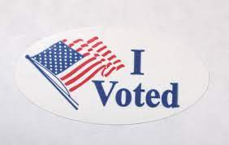***

***Community Presentation on Redistricting. . .***

**DATA REVEALS GET OUT THE VOTE CHALLENGES**

On February 23, 2021, Dr. Vicky Ybarra presented data to inform local efforts for “Improving Representation in Yakima County for People of Color Through Redistricting in 2021.” This first in a series of community presentations (*see schedule and article on p. 2 for second presentation*) detailed voter turnout.

Graphs illustrated the drop off between each category: Adult Population, Citizen Voting Age Population (excluding adult non-citizens), Registered Citizens, and Voters in 2016. Overall in Yakima County, 68% of Citizens of Voting Age cast ballots. Among white voters in our county, the figure was 77%, but the percentage drops for Black, Indigenous, and People of Color communities, ranging from 65% to 45% of Citizens of Voting Age actually sending in their ballots.

Research indicates that neighborhood mobilization and personal contact is most effective in increasing citizen participation in voting. This reinforces how important community liaisons are to the voter registration and get out the vote work of our League of Women Voters.

***The Voter,*** *March, 2021 Page 4*

***March League Conversation Preview. . .***

**DISCUSSION TO FOCUS ON AFFORDABLE HOUSING**

For our March League Conversation, Jake Mayson, Government Affairs Director for the Central Washington Home Builders Association (CWHBA), will lead a discussion on Affordable Housing in Yakima County. Also contributing will be Joseph Calhoun, Planning Manager for the City of Yakima. Their presentation will be on **Tuesday, March 23, at 5:30 PM**, at the Zoom link: [**https://us02web.zoom.us/j/9065780972**](https://us02web.zoom.us/j/9065780972)**.**

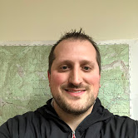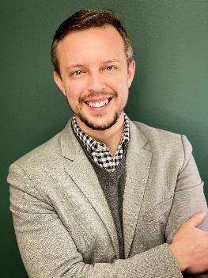Jake Mayson studied Political Science at WSU and worked with Washington State politics as a senate staffer, manager of political races, lobbyist for Associated Builders and Contractors and the Architects and Engineers Legislative Council, and director of a Political Action Committee focused on municipal government. As Government Affairs Director for CWHBA, Jake works closely with local governments and other organizations across 6 counties to enable a homebuilding process that serves the CWHBA members and consumers.

Jake Mayson

With a BA in Geography from CWU, Joseph Calhoun started with the City of Yakima in 2007 as an Assistant Planner, becoming Planning Manager in 2017. The Planning Division is primarily

Joseph Calhoun

responsible for Zoning, Land Use, Subdivision, and Environmental Review.

***February League Conversation Recap. . .***

**YSD DIRECTOR WORKS FOR EQUITY TO IMPROVE EDUCATION**

Marcus Pimpleton, shared his efforts and experiences as Yakima School District’s first Executive Director of Equity, Partnerships and Student Engagement. An award-winning teacher with an expansive academic resume – 7 college degrees and completion of a second doctorate in June, 2021 – he credits his grandparents for their legacy of faith, work ethic, and belief that he could become whatever he wanted. He also acknowledges his participation in the State School Leaders Program as important to his learning to engage and move systems.

Mr. Pimpleton’s first year with YSD has focused on helping school colleagues define racial and educational justice and centering the race challenge. While race is most difficult to talk about, true antiracist capacity building will help all students who struggle. He stressed that equity doesn’t mean “everyone gets the same meal.” Rather, it means that each person has opportunity so that group membership does not predict life outcomes. Intent does not always equal outcome. The way that practices and policies are created will have to change, utilizing an equity lens.

He has been working across the district with the school board, district leaders, and in school buildings to establish a common language as a necessary step toward aligning behavior and practice with stated beliefs. Efforts to shift policy give rise to conflicts, tensions and contradictions. Dr. Pimpleton believes in listening, but also leaning into the tensions. Asking questions can lead to what is termed “co-design,” which means doing with and not to families, communities, students, and staff.

Marcus Pimpleton acknowledges that buy-in is an ongoing struggle. He tries to be approachable and has begun with those who are willing. But he is also aware of the obligation for change, which can’t wait for everyone to “be ready.”

***The Voter,*** *March, 2021 Page 5*

***Opportunities for League Involvement. . .***

**STATE LEAGUE ANNOUNCES AFFINITY GROUPS**

The State league is fostering **Affinity Groups** for local Leagues organized around specific concerns and activities. If any of the following stir your interest, please contact the coordinator directly. Criss would also like to know of your interest.

**Two New Affinity Groups Forming!**

*Observer Corps:* Would you like to start an Observer Corps for your League? Email Linda Benson, [lbenson@lwvwa.org](file:///C:\Users\susanlkap\Downloads\lbenson@lwvwa.org), and get connected!

*Membership Development*: How does your League welcome new members and get them involved? Join a new group discussion. Email Linda Benson, [lbenson@lwvwa.org](file:///C:\Users\susanlkap\Downloads\lbenson@lwvwa.org), and enjoy an exchange of ideas.

**Join an already established Affinity Discussion Group:**

*Criminal Justice*: Deb Carstens, [dcarstens@lwvwa.org](file:///C:\Users\susanlkap\Downloads\dcarstens@lwvwa.org)

*Gun Safety:* Pat Griffith, [pgriffith@lwvwa.org](file:///C:\Users\susanlkap\Downloads\pgriffith@lwvwa.org)

*Health Care*: Kim Abbey, [kabbey@lwvwa.org](file:///C:\Users\susanlkap\Downloads\kabbey@lwvwa.org)

*Public Bank*: Ruth Fruland, [rfruland@lwvwa.org](file:///C:\Users\susanlkap\Downloads\rfruland@lwvwa.org%20) and Stoney Bird, [sbird@lwvwa.org](file:///C:\Users\susanlkap\Downloads\sbird@lwvwa.org)

*Responsible Journalism*: Dee Anne Finken, [dfinken@comcast.net](file:///C:\Users\susanlkap\Downloads\dfinken@comcast.net)

*Webmaster/Communication*: Delores Irwin, [deloreslwv@gmail.com](mailto:deloreslwv@gmail.com)

***Facilitating League Goal . . .***

**DOES CIVIC EDUCATION INTEREST YOU?**

Our League needs a “Point Person” for our Civic Education efforts. We have so many opportunities for activities, including promoting the LWVWA textbook publication, *The State We’re In,* which is now out in both high school and grades 3-5 editions, as well as a Spanish translation on line. A publication order of 30 books comes with a Teacher’s Guide and is a perfect textbook for use in fulfilling the new graduation requirement for a mandatory stand-alone course in civics for each WA State high school student. In 2019 we were able to introduce the high school edition to the superintendents of ESD 105, but we have not done any follow-up since then.

Although our contacts with Heritage College waned in the last couple of years, we believe we could also rebuild our efforts there to help students and facility increase their civic engagement.

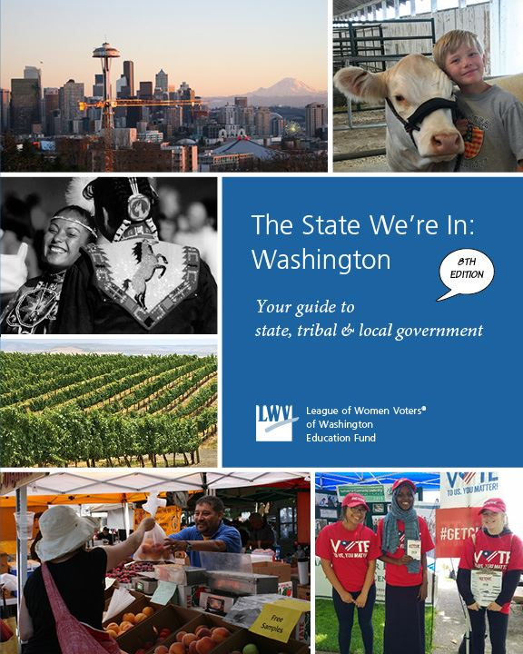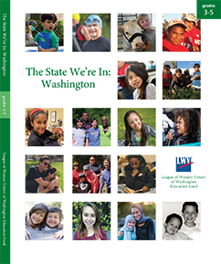Civic Education is a primary goal and function of the League of Women Voters, and any member that might be interested in getting involved could count on strong support from the Leadership Team as well as the right to set limitations on how much they wanted to take on. Please let Criss know if you want to talk about this opportunity – she promises no assumption that a discussion will lead to a commitment! Criss is available at [cbardill@gmail.com](mailto:cbardill@gmail.com) or 965-2351.

Text for Grades 3-5

Text for Middle School & up

***The Voter, March, 2021 Page 6***

**LEAGUE OF WOMEN VOTERS OF WASHINGTON**

**STATEMENT ON DIVERSITY**

The League of Women Voters is an organization fully committed to diversity, equity, and inclusion in principle and in practice. Diversity, equity, and inclusion are central to the organization’s current and future success in engaging all individuals, households, communities, and policy makers in creating a more perfect democracy.We will actively work to remove barriers to full participation in this organization on the basis of gender, gender identity, ethnicity, race, native or indigenous origin, age, generation, sexual orientation, culture, religion, belief system, marital status, parental status, socioeconomic status, language, accent, ability status, mental health, educational level or background, geography, nationality, work style, work experience, job role function, thinking style, personality type, physical appearance, political perspective or affiliation and/or any other characteristic that can be identified as recognizing or illustrating diversity



**LEAGUE OF WOMEN VOTERS**

**OF YAKIMA COUNTY**

**Empowering Voters. Defending Democracy.**

Name:\_\_\_\_\_\_\_\_\_\_\_\_\_\_\_\_\_\_\_\_\_\_\_\_\_\_\_\_\_\_\_\_\_\_\_\_\_\_\_\_\_\_\_\_\_\_\_\_\_\_\_\_\_\_\_\_\_\_\_\_\_\_\_\_\_\_\_\_\_\_\_\_

Address\_\_\_\_\_\_\_\_\_\_\_\_\_\_\_\_\_\_\_\_\_\_\_\_\_\_\_\_\_\_\_\_\_\_\_\_\_\_\_\_\_\_\_\_\_\_\_\_\_\_\_\_\_\_\_\_\_\_\_\_\_\_\_\_\_\_\_\_\_\_\_

Phone Numbers:

Home\_\_\_\_\_\_\_\_\_\_\_\_\_\_\_\_\_\_\_Work\_\_\_\_\_\_\_\_\_\_\_\_\_\_\_\_\_\_Cell\_\_\_\_\_\_\_\_\_\_\_\_\_\_\_\_\_\_

Email\_\_\_\_\_\_\_\_\_\_\_\_\_\_\_\_\_\_\_\_\_\_\_\_\_\_\_\_\_\_\_\_\_\_\_\_\_\_\_\_\_\_\_\_\_\_\_

**Membership Categories:**

   \_\_\_\_\_\_\_$60 Basic\*

   \_\_\_\_\_\_\_$40 Each additional family member at the same residence

  \_\_\_\_\_\_\_$10 Student Associate

Sustaining Gift:  $60 \_\_\_\_\_ $40 \_\_\_\_\_ $25 \_\_\_\_\_ Other:\_\_\_\_\_\_\_ Your Sustaining gift will help support our local activities.                                                                               

**\*Please Note Dues Distribution:** National: $32

**Make checks payable to: LWVYC Mail to: PO Box 723**

**YAKIMA WA 98907**

              State:   19

                              LWVYC retains: 9

$60

***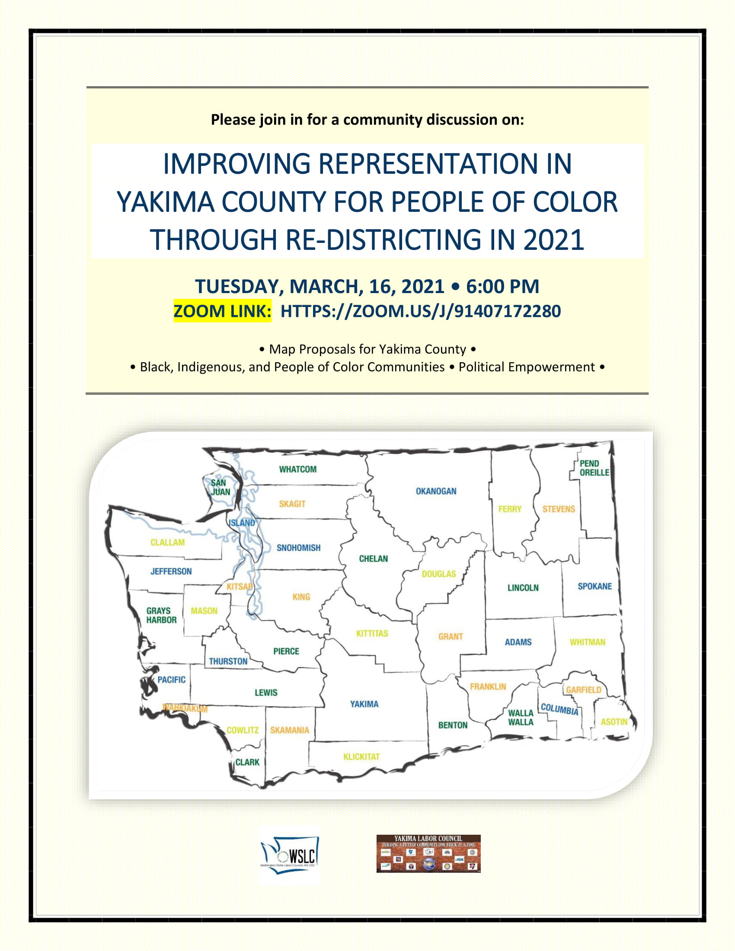***

***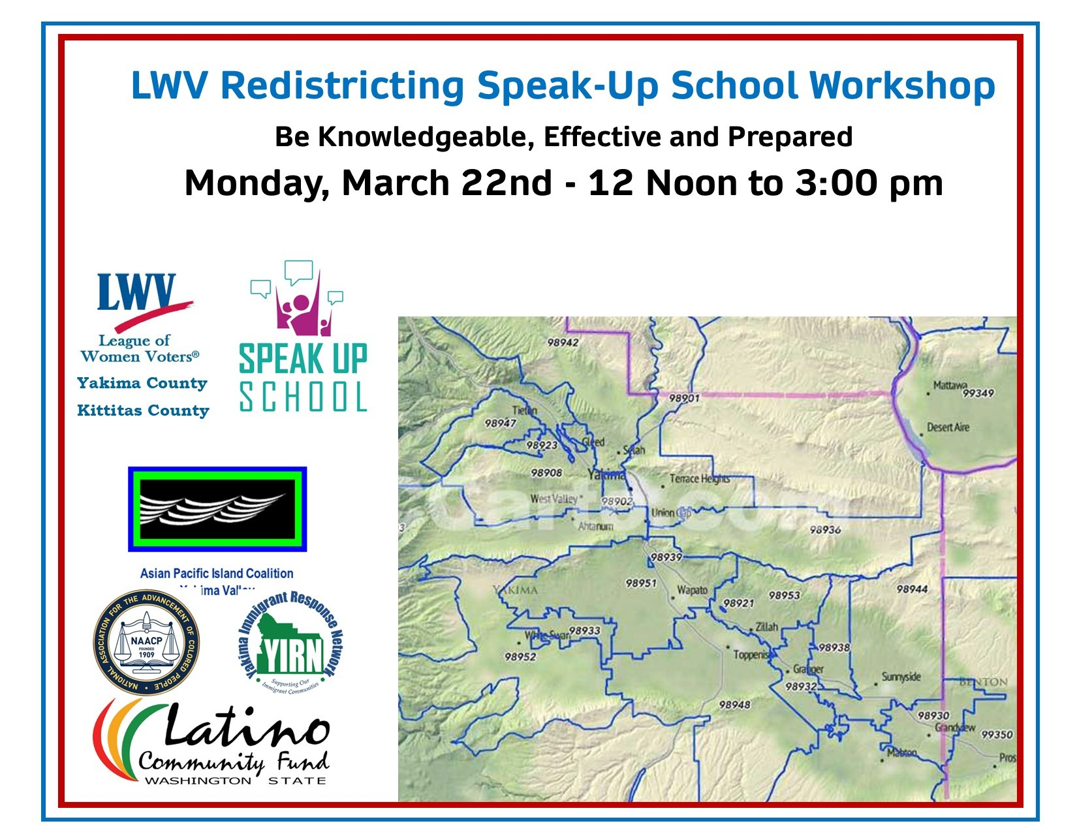***

**Register at:** [**http://tinyurl.com/SpeakUpMar22**](http://tinyurl.com/SpeakUpMar22)