THE OTER

This Newsletter published by and for the League of Women Voters of Yakima County PO Box 723 Yakima WA 98907 509-452-3419
We respectfully acknowledge that we are on the traditional land of the Yakama People.

August, 2020 Vol.20, No 8

MISSION STATEMENT Empowering Voters. Defending Democracy.

VISION
We envision a democracy where every person has the desire,
the right, the knowledge, and the confidence to participate.

VALUE STATEMENT
The League believes in the power of women to create a more perfect democracy.

Officers President: Criss Bardill Secretary: Karen Pilon Treasurer: Janis Luvaas

Leadership Team Quinn Dalan Rhona Hauff
(also Membership) Kitty Jubran
Susan Kaphammer Cheri Kilty
Kathy Lambert Anita Monoian Lee Murdock

Voter Editor: Susan Kaphammer 949-0127; susanlkap@gmail.com

The Board currently meets at 4:30 PM the 1st Monday of each month via Zoom. All members are welcome.
Contact Criss Bardill at 509-965-2351 or at cbardill@gmail.com to “attend”
CALENDAR

Sunday, August 23, 1:00 PM Black Voter Suppression: Election 2020. Livestream. Information and registration at www.townhallseattle.org. Free. See article below.

Tuesday, August 25, 5:30 to 7:00 PM League Conversation: Washington State Long Term Care Act by Cathleen MacCaul. Via Zoom. See article below. Zoom link: https://us02web.zoom.us/j/9065780972

Monday, September 14, 4:30 PM. Leadership Team Meeting. Via Zoom. Note: Postoponed one week due to Labor Day.

LWVYC President’s Column…

NOTES FROM CRISS

It sure feels like the dog days of the summer of 2020 to me – too hot; Covid 19 not going away anytime soon; lots of worrisome news on the political front. But I tell myself it’s all the more reason to be engaged and active in our vital work of Empowering Voters and Defending Democracy.
To that effort, we are still working on the details of hosting a virtual and possibly televised Gubernatorial Debate in early October, which would focus on the concerns and issues of Central Washington.
And the Leadership Team agreed to pursue a local virtual forum with our two Yakima County Commissioner candidates. We will be contacting both candidates this coming week with hopes of setting a date in September.
We are also restarting our League Conversations in Zoom format. (See article below and flier.) We hope this will be an opportunity to reconnect and hear from some interesting speakers on some edifying topics.
Continued on Page 2
The Voter, August, 2020 Page 2

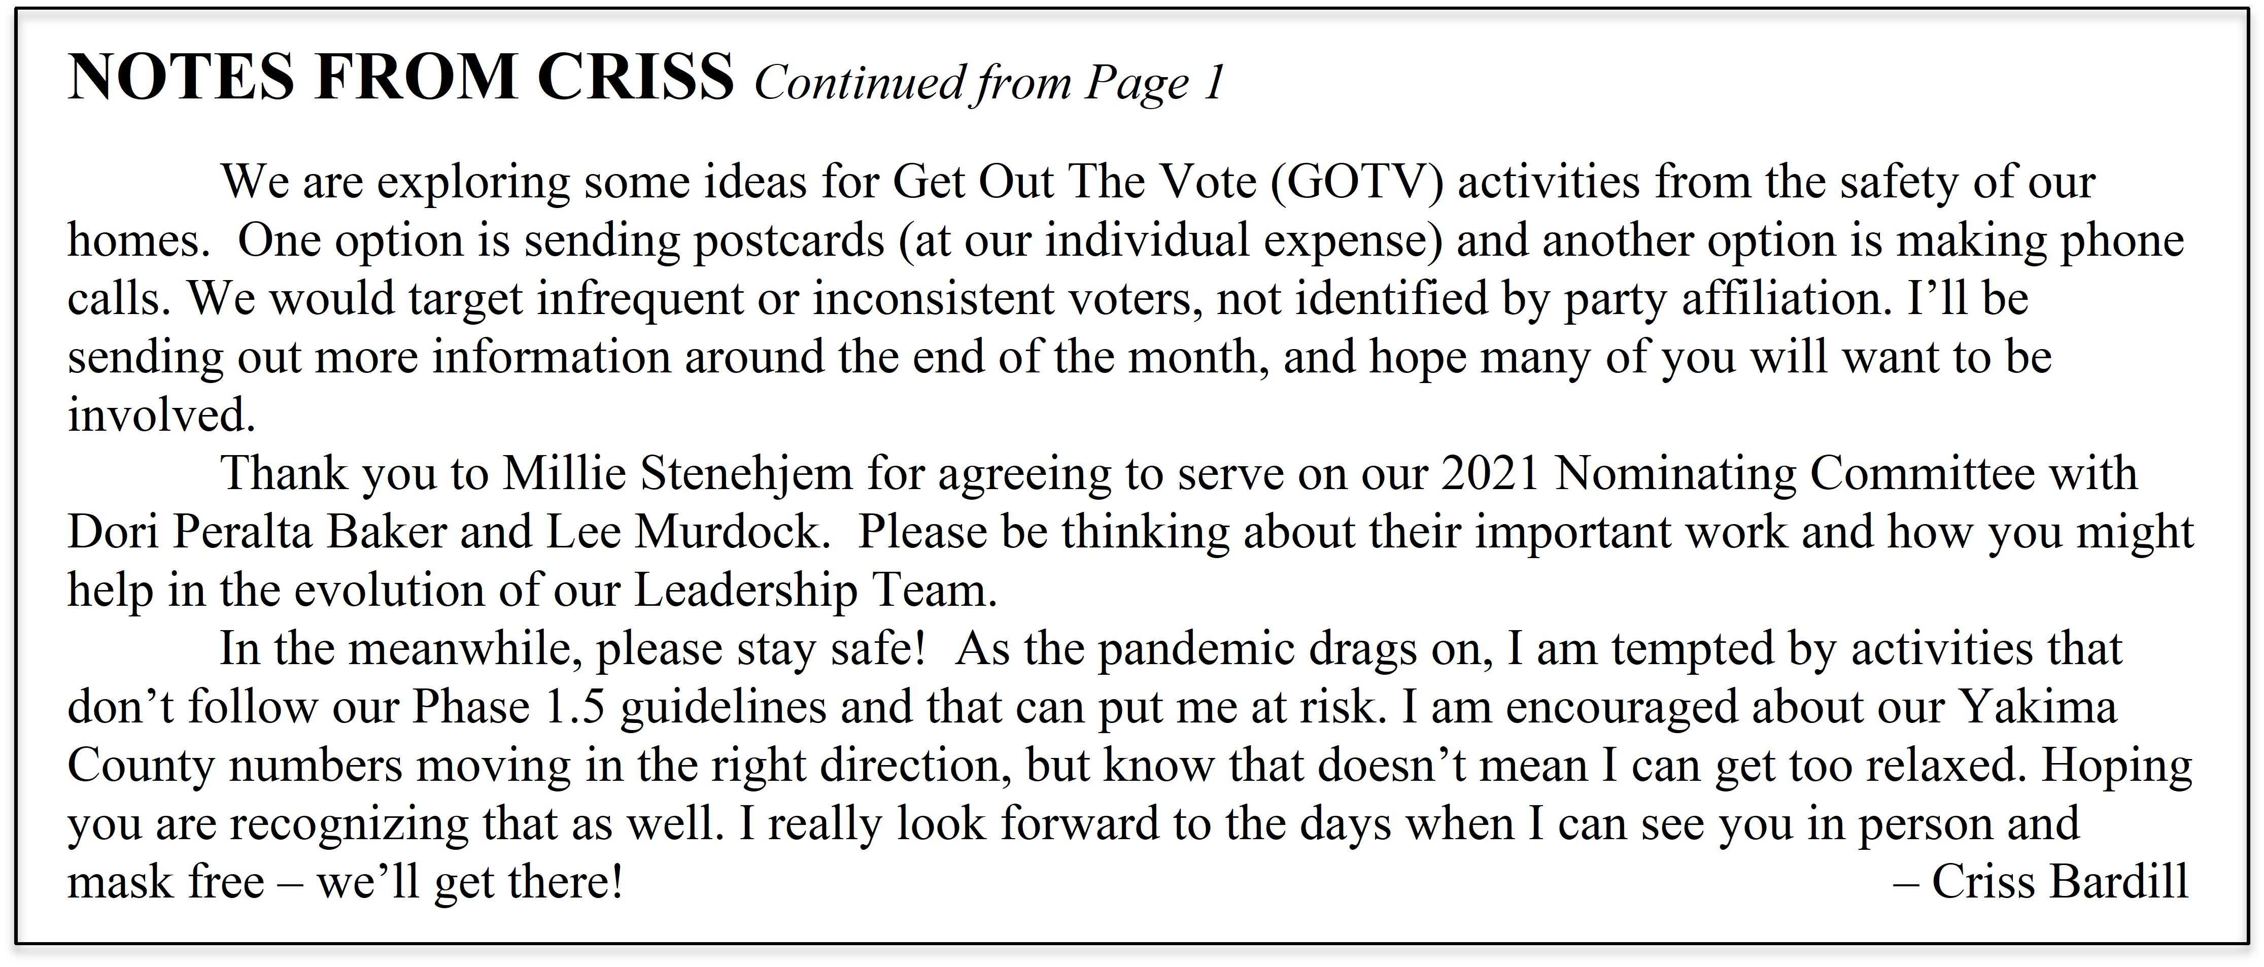
August Conversation. . .

STATE LONG TERM CARE ACT EXPLAINED

After a five-month delay due to the coronavirus, the League Conversation Series will resume with the previously postponed presentation on the Washington State Long Term Care Act scheduled for 5:30 PM on Tuesday, August 25.
The 2019 Washington State Legislature created a long-term care benefit for workers and families who do not have long-term care insurance and find themselves unable to pay for necessary health and care services. Washington workers pay into a trust through a payroll assessment and are then able to become eligible for benefits that help with a range of daily tasks, ranging from bathing and dressing to taking medicine.
Cathleen MacCaul will be sharing information and answering questions about this new plan.
She is the Advocacy Director for AARP Washington State where she manages government relations and legislative affairs to support policies serving the 50+ population. AARP has nearly one million members in the state and she has worked on a variety of policies related to long term care, prescription drugs, health care, retirement savings and property taxes. She has worked for some of the leading nonprofit organizations including World Vision and YWCA addressing global and domestic public health, poverty and economic justice issues. She also worked for Microsoft advance information access and digital inclusion to underserved and underrepresented communities. Cathleen has a Master’s in Policy Studies from the University of Washington – Bothell.
This Conversation will be offered via ZOOM at https://us02web.zoom.us/j/9065780972 To connect by phone for audio only, dial 1-253-215-8782; when prompted, enter the Meeting ID: 906 578 0972.

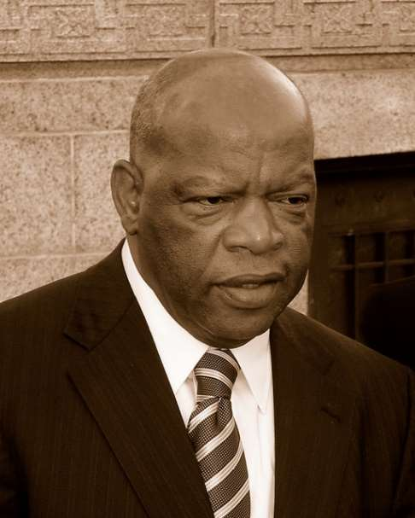
Lest We Forget. . .

LESSONS FROM JOHN LEWIS (1940-1920)

The vote is the most powerful nonviolent change agent you have in a democratic society. You must use it because it is not guaranteed. You can lose it.

Though I am gone, I urge you to answer the highest calling of your heart and stand up for what you truly believe.
The Voter, August, 2020 Page 3

Action Requested ! !

BROADBAND SURVEY NEEDS WIDESPREAD INPUT

We are encouraging your participation in the Washington State Department of Commerce Broadband survey to help the state prioritize locations most in need of help with gaps in internet and broadband service. This is the case in some of our Yakima County rural areas!
Universal access to broadband service has become increasingly important for businesses and families. Improvements are essential now that we realize many of our students across the county do not have the access to the internet to participate in remote learning.
For the quick survey, fill in your location information and broadband will be automatically calculated at: https://www.commerce.wa.gov/building-infrastructure/washington-statewide-broadband-act/speedtestsurvey/

New Member to LWVYC…

WELCOMING KARRI JO LIVINGSTON

I most recently retired on June 30, 2020 after a long career as an advocate for children and families. I am a graduate of both the University of Washington and Central Washington Universities. My professional experiences include twenty-nine years in varying positions with the State of Washington. My positions included CPS worker, Child Welfare Social Worker, Child Placing Agency Licensor, Child Care Center Licensor and Regional Child Care Manager. I completed my career with the state as a Service Area Manager for the Department of Early Learning.
Shortly thereafter, I began my second career as an Early Learning Associate Director with EPIC and ended my 40-plus-year professional career as the ECEAP Director for EPIC.
I have been married for thirty-three years to my husband Ron and we have one son Chase who is a Family Medicine physician in the Yakima Valley. Chase and his wife Paige have blessed us with our granddaughter Everly Ann.
In October I will assume the duties of the president for the Kiwanis Club of Yakima. I eagerly look forward to exploring the numerous opportunities available for volunteering within our local community.

Issue for League Attention…

VOTER SUPPRESSION THREATENS DEMOCRACY

FILM AND DISCUSSION HIGHLIGHTS ISSUE: Celina Stewart, League member, is featured guest speaker for the town hall discussion and film screening on the crucial issue of voter suppression. Hosted by Town Hall Seattle, the free livestreamed event is offered at 1:00 PM Sunday, August 23. Once registered, the confirmation email will provide links to watch the event live or to watch anytime you like. Learn more and register at https://townhallseattle.org/event/14th-annual-urban-poverty-forum-livestream/.
NATIONAL LEAGUE JOINS POSTAL SERVICE SUIT: Joining other civil and voting rights organizations, LWVUS is suing to stop changes in postal service and restore operations. Virginia Case, CEO explained, “We never imagined that we would be in this position with one of the oldest and most trusted institutions in our country. We need guarantees in place that this will not happen again, prior to the election.” (Source: Yakima Herald Republic, August 20, 2020, p. 7A)
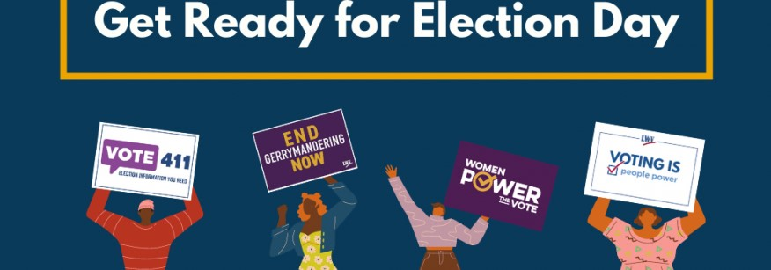
The Voter, August, 2020 Page 4

Individual and Organizational Action…

Having passed 100 days to the 2020 Election, important dates are looming. September 22 is National Voter Registration Day. In Washington State, the online and by mail deadline for new registrations and voter updates is October 26. In person registrations and voter updates will be accepted at county election offices through Election Day. Voting in Washington State begins October 16 and ends at 8:00 PM on the General Election Day – November 3, 2020.
Three weeks later, on November 24, County Canvassing Boards certify and transmit results of the election. December 3 is the last day for the Secretary of State to certify the General Election results.
Given the importance of this election, how can we take action, get involved and make a difference? Cecilia Calvo of LWVUS offers 100 suggestions, some of which are reprinted below. Her entire article can be read at: https://www.lwv.org/blog/100-days-and-100-ways-get-ready-election-day?utm_source=newsletter &utm_medium=email&utm_campaign=072620.

✓ Check your voter registration on VoteWA at https://voter.votewa.gov/WhereToVote.aspx. It’s always good to check the information your local election official has on file for you.

✓ Ask 10 people you know if they’re registered to vote or if they need to update their registration. Make it a community affair by ensuring your family and friends are prepared to vote.

✓ Know someone who will be voting for the first time? Share our First Time Voter Checklist at https://www.vote411.org/first-time-voter-checklist to help make sure they're prepared.

✓ Have friends or family who speak Spanish? Let them know that VOTE411.org is fully translated into Spanish at https://www.vote411.org/es so they can find all the election information they need.

✓ Reach out to your local senior center and make sure their residents are registered to vote and have the information they need to safely participate in the upcoming election.

✓ Demand action from Congress to protect the 2020 election. Ensure voting remains fair, accessible, and safe. Voters should not have to choose between their health and their vote. Call your Senators today at 1-888-415-4527 to ask them to include $4 billion in funding to secure our elections in the next stimulus package (or fill out the LWV contact form at http://participate.lwv.org/c/10065/p/dia/ action4/common/public/?action_KEY=13932&_ga=2.115651590.1494744857.1597958770-1793876382.1597958770).

✓ Spread the word about VOTE411.org at https://www.vote411.org/; every voter’s one-stop-shop for the election information they need.

Select an action, or two, or three; team up or pursue on your own, and let’s make a difference!
The Voter, August, 2020 Page 5

LWV WA Statement…

DIVERSITY POLICY

The League of Women Voters is an organization fully committed to diversity, equity, and inclusion in principle and in practice. Diversity, equity, and inclusion are central to the organization’s current and future success in engaging all individuals, households, communities, and policy makers in creating a more perfect democracy.
We will actively work to remove barriers to full participation in this organization on the basis of gender, gender identity, ethnicity, race, native or indigenous origin, age, generation, sexual orientation, culture, religion, belief system, marital status, parental status, socioeconomic status, language, accent, ability status, mental health, educational level or background, geography, nationality, work style, work experience, job role function, thinking style, personality type, physical appearance, political perspective or affiliation and/or any other characteristic that can be identified as recognizing or illustrating diversity.

LEAGUE OF WOMEN VOTERS YAKIMA COUNTY

Empowering Voters. Defending Democracy.

Name:________________________________________________________________________

Address_______________________________________________________________________

Phone Numbers:

Home___________________Work__________________Cell__________________

Email_______________________________________________

Membership Categories:

_______$60 Basic*

_______$40 Each additional family member at the same residence

_______$10 Student Associate

Sustaining Gift: $60 _____ $40 _____ $25 _____ Other:_______ Your Sustaining gift will help support our local activities.

*Please Note Dues Distribution: National: $32 State: 19 LWVYC retains: 9
$60

Make checks payable to: LWVYC Mail to: PO Box 723
YAKIMA WA 98907
League of Women Voters of Yakima County

Presents League Conversation Series

WASHINGTON STATE LONG TERM CARE ACT
The 2019 Washington State Legislature created a long-term care benefit for workers and families who do not have long-term care insurance. Payroll assessment will fund a trust to help those eligible pay for necessary health and care services.

Find out more about this program.

Presented By Cathleen MacCaul
Advocacy Director for AARP WA State

Tuesday, August 25 at 5:30 to 7:00 PM
Via ZOOM: https://us02web.zoom.us/j/9065780972 By phone for audio only: 1-253-215-8782 Meeting ID: 906 578 0972

