THE OTER

V



This Newsletter published by and for the

League of Women Voters of Yakima County

PO Box 723, Yakima, WA 98907 509-452-3419

*We respectfully acknowledge that we are on the traditional land of the Yakama People.*

April, 2021

Vol.21, No 4

**CALENDAR**

Saturday, April 24, 4:00 – 6:30 PM **Many Maps, One Voice.** Video on Redistricting; Follow-up comments by Sara Augustine, WA Commission Chair and LWVYC Member! Via Zoom. $25 contribution. Register at: <https://us02web.zoom.us/webinar/register/3716173018578/WN_677ndhjWSBqmVqGhVNlTqw> *See article on pp 2-3.*

April 22 – April 25 **Stand Against Racism.** 4 events sponsored by YWCA and other community organizations. *See attached flier.*

Tuesday, April 27, 5:30 PM **Community Conversation: Community Policing** by Chief Matt Murray, Yakima Police Department. Via Zoom or stream on LWVYC Facebook page. *See announcement below.*

April 27 – April 30 **Central Washington Conference for the Greater Good.** Online. $60. Info and registration at <https://whova.com/portal/registration/cwcgg_202104> Scholarship contact: [nancy@nancybacon.com](mailto:nancy@nancybacon.com).

Monday, May 3, 4:30 PM **Leadership Team Meeting.** Via Zoom. *Watch email for Zoom link.*

**MISSION STATEMENT**

Empowering Voters. Defending Democracy.

**VISION**

We envision a democracy

where every person has the desire,

the right, the knowledge, and the confidence

to participate.

**VALUE STATEMENT**

The League believes in the power of women to create a more perfect democracy.

March 26

+-

**Officers**

*President:*  Criss Bardill

*Secretary:* Karen Pilon

*Treasurer:* Janis Luvaas

**Leadership Team**

Quinn Dalan

Rhonda Hauff

(*also Membership*)

Kitty Jubran

Susan Kaphammer

Cheri Kilty

Kathy Lambert

Lee Murdock

*Voter Editor:* Susan Kaphammer

949-0127; susanlkap@gmail.com

The Board currently meets at 4:30 PM

the 1st Monday of each month via Zoom.

**All members are welcome.**

Contact Criss Bardill at 509-965-2351 or at [cbardill@gmail.com](mailto:cbardill@gmail.com) to “attend”

*Community Conversation…*

**COMMUNITY POLICING**

With **Chief Matt Murray**

**Yakima Police Department**

**Tuesday, April 27, 2021**

**5:30 PM**

Join at Zoom Link (information forthcoming)

Or Watch Live on the LWVYC Facebook Page

*League Conversations:*

*Informing the public on topics of interest.*

*Page 2*



**co**

***The Voter,*** April*, 2021 Page 2*

***LWVYC President’s Column…***

**NOTES FROM CRISS**

As I write this, [10 days ago – my how our weather changes! – *Editor*] a cold wind is whipping around outside, although the sun is out!  Spring in Yakima is here, along with blooming cherry and plum trees, forsythia, tulips, daffodils, candy tuff, phlox, irises and much more coming.  And our vaccination rates are increasing dramatically leading to hope for a more “normal” year ahead.

We have received word from the YUU Church that their building is being sold and we will need to vacate our office there by June 1.  The Unitarians have been wonderful and generous hosts for many years, but this provides an opportunity to lower our fixed expenses.  We have been invited to use the YWCA as our Leadership Team meeting location at no cost, as well as for other events or work parties when it works with their schedules.  We will need some storage and are working on that. But we do not plan on keeping our office furnishings, only records and supplies that can be stored in bins and boxes.  Sorting and clean-out efforts are underway; watch for emails that may give the opportunity to help with this move.

The final elements of our Speak Up School project are practice sessions for testifying. A small number of people took part in a Zoom practice on April 12. Additional Testimony Practice will be rescheduled closer to the 2021 Redistricting Commission's Public Hearings for the 13th, 14th, and 15th Legislative Districts this summer. This months’ long effort spearheaded by Dori Peralto Baker has educated and trained over 48 people on the redistricting process and preparing to testify at a Redistricting Committee hearing.  Dori brought together co-sponsors from the BIPOC communities and the Kittitas County League was also a co-sponsor, so it was truly a Central WA effort.

Quinn Dalan has been organizing League Conversations this year that have been very interesting and timely. The Conversations are scheduled for 5:30 PM on the 4th Tuesday of the month, and I encourage you to Zoom in to hear local people talk about local and regional issues.  We will begin meeting in person again when that becomes possible, but in the meantime, Zoom is a very easy opportunity to attend these events.

The Leadership Team is planning to hold a primary candidate forum for the Yakima City Council candidates prior to the August 3rd primary.  It is unclear at this time if we will be on Zoom or live with an audience.  If you are interested in being involved in this effort, please let me know.  It takes a village to do a candidate forum! – Criss Bardill

***Inspiring Video and Commentary…***

***MANY MAPS, ONE VOICE* PORTRAYS CITIZEN ACTIVISM**

***Many Maps, One Voice***, adapted from the book *Politics of the Possible*, tracks the redistricting journey of Mary Ellen McCaffree, played by veteran stage actress Jane Fellows (*Belle of Amherst*, *The Trip to Bountiful*, *First Lady Lou*). Don’t miss this compelling story of a housewife and mother of five who took on the problem of her kids’ ill-funded schools and found herself thrust center stage in the fight for one person – one vote. You’ll recognize political parallels to today – dysfunction, obstruction, partisan ploys, and also leaders firmly focused on *We the People.*

Timely and timeless, *Many Maps* is a call to civic engagement, citizen action and civility in the ongoing voting rights fight inherent in the census and redistricting. Join us **Saturday, April 24th, 4:00 to 6:30 PM** at the online premiere of *Many Maps, One Voice*.

*(continued on Page 3)*

***The Voter,*** *April, 2021 Page 3*

*(MANY MAPS, ONE VOICE continued from Page 2)*

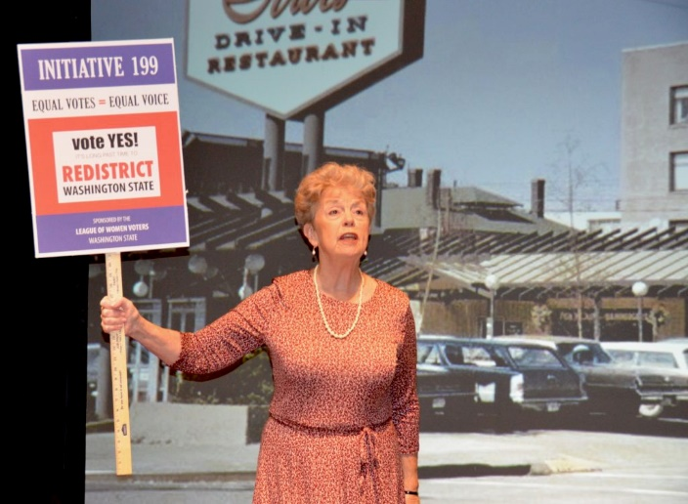  The premiere of this video version of the stage play will be introduced by former Washington State Secretaries of State: Sam Reed and Ralph Munro, as well as current Washington State Treasurer Mike Pellicciotti. Post show, the actor, writer and producers will discuss the project.

](https://politicsofthepossible.us17.list-manage.com/track/click?u=677bbcaade900833ac6fc2e33&id=9b65675550&e=bfc10fcf38)

*Jane Fellows as Mary Ellen McCaffree advocating for redistricting reform circa 1958.*

Our current Washington Redistricting Commission Chair Sarah Augustine (local League member!) will also share her thoughts on the play and how its messages are relevant to today's redistricting process.

A $25 donation for the viewing is requested. The donation will support the video production expenses and help launch further redistricting education. Scholarships are readily available; please email: [alison@politicsofthepossible.com](mailto:alison@politicsofthepossible.com).

*Sarah Augustine*

[**REGISTER AND PAY HERE**](https://us02web.zoom.us/webinar/register/6716173018705/WN_677ndhjWSBqmVqGhVNlTqw)

<https://us02web.zoom.us/webinar/register/3216179280357/WN677ndhjWSBqmVqGhVNlTqw>

Politics of the Possible in Action is a registered nonprofit corporation in the State of Washington. Alison McCaffree serves as the founding director of this nonprofit founded in 2017. Inspired by the philosophies of her grandmother, Mary Ellen McCaffree, a former four-term state legislator, Alison created Politics of the Possible in Action to inspire community engagement and enhance civic education.

**"When legislators can entrench them- selves in officedespite the people's will — the foundation of effectivedemocratic governance dissolves."**  
 - Justice Elena Kagan, Gill v Whitford concurrence, June 18, 2018

**LEAGUE OF WOMEN VOTERS OF WASHINGTON**

**STATEMENT ON DIVERSITY**

The League of Women Voters is an organization fully committed to diversity, equity, and inclusion in principle and in practice. Diversity, equity, and inclusion are central to the organization’s current and future success in engaging all individuals, households, communities, and policy makers in creating a more perfect democracy.We will actively work to remove barriers to full participation in this organization on the basis of gender, gender identity, ethnicity, race, native or indigenous origin, age, generation, sexual orientation, culture, religion, belief system, marital status, parental status, socioeconomic status, language, accent, ability status, mental health, educational level or background, geography, nationality, work style, work experience, job role function, thinking style, personality type, physical appearance, political perspective or affiliation and/or any other characteristic that can be identified as recognizing or illustrating diversity

***The Voter,*** *April, 2021 Page 4*



**LEAGUE OF WOMEN VOTERS**

**OF YAKIMA COUNTY**

**Empowering Voters. Defending Democracy.**

**Cordially invites you to:  JOIN US!**

Name:____________________________________________     M**embership Categories:**

Address:__________________________________________     _______$10  Student

__________________________________________________     _______$60 Basic

Phone:____________________________________________     _______$40 Each

                                                                          Additional Family

Member at the Same

E-Mail: ___________________________________________      Residence

Sustaining Gift:  $60 _____ $40 _____ $25 _____ Other:_______ Your Sustaining gift will help support our local activities.

**Make checks payable to:** LWVYC

**And mail to:** LWVYC, PO Box 723, YAKIMA WA 98907

Please note: Our fiscal year is July 1 – June 30. Initial dues received before December 31 will be subject to renewal on June 30 of the following year. Initial dues received after January 1 will be subject to renewal on June 30 of the year following that year.

Examples: a) Initial dues paid October 10, 2020, renewal date June 30, 2021

               b) Initial dues paid February 24, 2021, renewal date June 30, 2022

