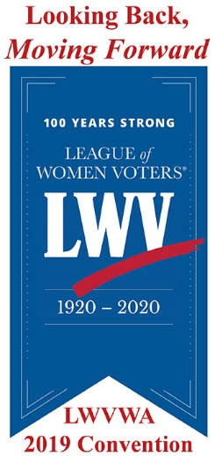
League of Women Voters of Washington
2019 Local League Awards

The purpose of these Awards is to recognize the work of Local Leagues that are making democracy work for all.

If you have questions about the nomination process, please contact: Lunell Haught, 509-443-1319, lh1@fastmail.com or info@lwvwa.org.

Deadline for nominations: May 1, 2019
Awards will be announced on June 8, 2019 at Convention.

I/we nominate the LWV of Local League Name for a Local League award(s). (May nominate in more than one category, use separate form for each.)

Nomination submitted by:
Name: Click here to enter text. | Phone: Click here to enter text.
Email: Click here to enter text.

Contact person(s) for nominated program or project:
Name: Click here to enter text. | Phone: Click here to enter text.
Email: Click here to enter text.

Please check the appropriate Award Categor(ies):
☐ Strengthening Democracy. Activated a grassroots network to empower voters and advocate change around key issues such as protecting voting rights or increasing voter registration and turnout.

☐ Community Connections. Leveraged issues affecting the local community in order to engage new voters and/or protect voters’ rights, especially among underrepresented communities.

☐ Effective Member Engagement and Recruitment. Sponsored innovative democracy-building and voter empowering programs and activities that improved the League’s visibility and recruited new members.

Name of project or program: Click here to enter text.

Brief description (500 words or less) of project or program. Include dates, numbers of participants, geographic area, voter turnout statistics, names of partner organizations, and other information:
Click here to enter text.

Describe how this project or program (Address those that apply):
Engaged new voters:
Click here to enter text.
Empowered voters:
Click here to enter text.
Protected voting rights:
Click here to enter text.
Increased voter registration:
Click here to enter text.
Increased voter turnout:
Click here to enter text.
Educated or informed voters:
Click here to enter text.
Built connections with other groups or individuals:
Click here to enter text.
Engaged new members:
Click here to enter text.
Increased attendance at meetings or events:
Click here to enter text.
Retained members and kept them engaged:
Click here to enter text.
Other positive outcomes:
Click here to enter text.

Was this project or program part of nominated league’s adopted Program of Work? ☐ Yes ☐ No

If there were unintended outcomes, what were they?
Click here to enter text.

Partner organizations or groups:
Click here to enter text.

Other information about project or program:
Click here to enter text.

To submit this nomination, please either email it to apeloff@lwvwa.org, or print it and mail it to:

LWVWA
1511 Third Ave, Suite 900
Seattle, WA 98101

